
All Citizens Christian Church Calgary
Bible Study: Tuesday, 14th, 2026. Topic: DIVINE GUIDANCE Part 3
PART 3: RECOGNIZING THE VOICE OF THE DIVINE — HOW GOD GUIDES THE BELIEVER
TEXT: 1 Samuel 16:1–13
MEMORY VERSE: "For as many as are led by the Spirit of God, these are sons of God." — Romans 8:14 (NKJV)
INTRODUCTION
In Parts 1 and 2 of this study, we explored the reality that God still speaks today and analyzed how drifting from His presence leads to spiritual deafness or the dangerous pursuit of ungodly, counterfeit voices. We observed how earthly kings faced life-altering battles depending on whether they sought true divine guidance or surrendered to flattering, false validation.
Now, we arrive at the most critical practical question: How do we actually receive and recognize this guidance?
Without divine direction, we are completely limited to human sight—operating as carnal (fleshly) men and women subject to mere statistics, guesswork, and probability. In our anchor text, even a seasoned prophet like Samuel was on the verge of making a monumental mistake by choosing Eliab based entirely on physical appearance. If a major prophet could almost miscalculate a king's ordination using natural senses, it proves that every human is highly prone to error without the illuminating counsel of the Holy Spirit.
To seamlessly hear from God, we must understand the spiritual "wavelength" on which He communicates. This requires mapping out the nature of God, the tripartite design of man, and the functional synergy required to convert divine revelation into everyday human decisions.
DISCUSSION SECTION
1. The Core Alignment: Who is God & How Does He Speak?
Before communication can occur, both parties must share a common operational medium. If two parties speak completely different languages or exist on incompatible frequencies, messages are lost.
- Question A: Based on John 4:24, what is the fundamental nature of God, and why does this explain why the physical human "flesh" cannot naturally perceive or communicate with Him?
  - Answer: John 4:24, "God is Spirit, and those who worship Him must worship in spirit and truth." Because God’s essential nature is non-physical and entirely spiritual, He does not use biological wavelengths to initiate contact. The carnal mind and physical flesh are tuned exclusively to the material world. Therefore, raw human strength or intellectual striving cannot decipher a spiritual God.
- Question B: 1 Corinthians 2:14. How does this verse describe the natural, unregenerate man’s capacity to process instructions that originate from the Spirit of God?
  - Answer: It states, "But the natural man does not receive the things of the Spirit of God, for they are foolishness to him; nor can he know them, because they are spiritually discerned." To the natural human intellect, divine instructions often defy logic and look like foolishness. Divine guidance requires a spiritual faculty to decode it.
2. The Tripartite Architecture of Man
To show us how God bridges this communication gap, Scripture reveals that man is not just a biological machine. Man is structurally designed as a tripartite (three-part) being.
1 Thessalonians 5:23: "Now may the God of peace Himself sanctify you completely; and may your whole spirit, soul, and body be preserved blameless at the coming of our Lord Jesus Christ." (See also Genesis 2:7).
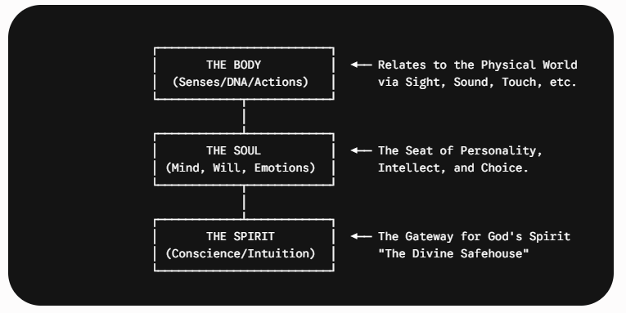
Let us break down the functions of the Spirit, the Soul, and the Body. Let us examine things in terms of how do they distinctively process data?
    - The Spirit: This is the core, eternal part of man that is regenerated at salvation. It is our spiritual command centre, containing our conscience, intuition, and capacity for God-consciousness. God connects with us exclusively through our spirit. (Proverbs 20:27). The spirit of a man is the lamp of the Lord, searching all the inner depths of his heart. John 4:24
    - The Soul: This consists of the mind (intellect/rationality), the will (choices/volition), and the emotions (feelings). It is the seat of self-awareness and human personality. It acts as a processing engine that translates spiritual impressions into practical, logical comprehension. Luke 1:46 And Mary said: “My soul magnifies the Lord,
Psalm 103:1-2: Bless the Lord, O my soul; and all that is within me, bless His holy name!
2 Bless the Lord, O my soul, and forget not all His benefits:

    - The Body: This is our physical tent composed of highly organized DNA. It interacts with the material world via the five senses (sight, hearing, touch, taste, smell) and it is mortal. I Cor 6:19 Or do you not know that your body is the temple of the Holy Spirit who is in you, whom you have from God, and you are not your own? I Cor 15 speaks a lot about the physical body. The physical body is subject to death but the spirit does not die.
- Question B: If God communicates directly to a believer's spirit, what happens if a believer's soul (mind) or body (senses) is completely untrained or unruly?
- Who is at fault when a believer falls into catastrophic errors that could have been avoided?
  - Answer: The fault rests entirely on the believer's lack of spiritual cultivation, not on God's willingness to speak. If the soul is cluttered with anxiety, carnal logic, or emotional noise, it acts like static on a radio. It drowns out the pure transmission coming from the Holy Spirit into our human spirit. To hear clearly, the soul must be disciplined and renewed by the Word (Romans 12:2).
3. Cultivating the Faculties of Divine Guidance (How do you cultivate)?
Hearing God is a dynamic, lifelong process that requires deliberate spiritual development. We must move past a reactive, crisis-only relationship with God and learn to master His communication channels.
- Question A: Examples-How does the accounts in 1 Samuel 3:1–11 (young Samuel) compare with that of Elijah in I Kings 19:9-13 (Elijah) and how do they teach us about how God's voice manifests, and why does Eliab's rejection in 1 Samuel 16:6–7 reinforce the danger of reliance on physical data?
  - Answer: Samuel heard an audible expression but initially lacked the trained spiritual maturity to distinguish it from Eli’s voice; he had to learn the protocol of response ("Speak, Lord, for Your servant hears"). Elijah discovered that God was not in the shattering wind, the earthquake, or the raging fire, but in a "still small voice" (a gentle whisper). God's voice is rarely an intrusive, disruptive shout; it is a deep, quiet inward impression in our spirit. If we rely strictly on external data—just as Samuel initially looked at Eliab’s impressive physical height—we will consistently misidentify what God is actually ordaining.
- Question B: How do we practically exercise our spiritual senses (Skill)? Hebrews 5:13–14. "They say practice makes perfect" when learning to dialogue with God by faith rather than human logic?
  - Answer: Maturity through usage Hebrews 5:14."who by reason of use have their senses exercised to discern both good and evil." Just as Isaac had to progressively learn the distinct identity of the God of his fathers Spiritual Familiarity through daily application. (Genesis 28:10–16), We must practice interactive dialogue through consistent prayer (1 Thessalonians 5:17) and regular immersion in the Word, which serves as a lamp to our feet (Psalm 19:7–10; Proverbs 6:23). When we repeatedly act in faith on small inner promptings, our spiritual hearing sharpens for major life-altering decisions.
CONCLUSION
Divine guidance is not an esoteric, hit-or-miss lottery reserved for an elite few. It is the absolute covenant birthright of every single born-again believer. Because God is Spirit, He bypasses external, fleshly appearances and drops His guidance directly into the container of our regenerated human spirit.
When we remain carnal, living entirely by the limitations of our five physical senses, we forfeit supernatural intervention and remain at the mercy of statistical failures. To step out of the realm of human guesswork, we must intentionally quiet the noise of the soul, bring our physical actions into alignment with Scripture, and intentionally train our spiritual faculties to recognize the "still small voice" of our indwelling Counselor.
GENERAL PRAYER POINTS
- Father, deliver me from spiritual deafness and carnal blindness. Forgive me for the times I have relied on my own intellect, statistics, and sensory data while ignoring Your Spirit.
- Lord, refine and sensitize my human spirit. Rip away every worldly distraction, anxiety, and demonic static that is currently jamming my spiritual frequency.
- Oh Lord, grant me the grace of spiritual discernment. Give me the courage of Micaiah and the hearing of Samuel. Help me to immediately recognize Your voice and instantly filter out the voice of strangers, false prophets, and my own fleshly desires.
- Father, renew my mind and soul by Your Word. Let my intellect and emotions become sharp, cooperative tools that smoothly translate Your spiritual instructions into precise, everyday victories.
PROPHETIC DECLARATIONS
- I declare that I am a sheep of the Great Shepherd; therefore, I hear His voice clearly, and the voice of a stranger I will never follow!
- I decree that my spiritual ears are unstopped and my inner eyes are flooded with light. I will not wander in confusion, nor will I be a victim of deceptive timelines or fleshly miscalculations.
- Like the prophet Samuel, I step out of the realm of human guesswork. I receive the accurate precision of the Holy Spirit for my career, my family, and my destiny.
- I declare that my spirit, soul, and body are in perfect divine alignment. The Holy Spirit is the resident Commander of my life, and my steps are ordered by the Lord day by day, in Jesus’ mighty name. Amen!

