All Citizens Christian Church Calgary
Bible Study: Tuesday, April 9th, 2024. Topic: THE NEHEMIAH CHRISTIAN
Text: Nehemiah 1 and 2
When I began to prepare for this Bible study, I read a statement in one of the books I was using. It said there are three types of people:
- Those who do not know what is happening.
- Those who watch what is happening - Hanani.
- Those who make things happen - Nehemiah.
The aim of this Bible study is to put us into the third category. The reason for this is that God did not design anyone to be in the first two groups. God designed us with an assigned purpose on earth. We are all on earth to please God and fulfil His will. We cannot achieve this by been ignorant or by been nonchalant (indifferent). We can only fulfil God’s reason for making us when we make things happen.
Gen 1:28 Then God blessed them, and God said to them, “Be fruitful and multiply; fill the earth and subdue it; have dominion over the fish of the sea, over the birds of the air, and over every living thing that moves on the earth.
”I see purpose like eleven players on a soccer field itching to achieve one objective on the pitch, we may have the strikers, the attackers, the wingers, the defenders, goal keeper etc. These people have one purpose, and it is to get the ball into their opponent’s goal and to ensure that their opponent does not get the ball into their goal. Every player must fulfil his role to achieve the purpose of the game. The Apostle Paul compared this to the human body in I Cor 12 12-30. We are all players on earth or in the church.
The reason for this Bible Study therefore is to help us re-align our thoughts so we can start to think of our purpose on earth with a view to achieving what the Lord has set for us. Do not tell me that your purpose on earth is to become an engineer or whatever career you find yourself in so that you can earn money. Engineering may be a means to an end but not the ultimate purpose for your being on earth.
Who was Nehemiah? Neh. 1:1, 2:1, 9.
There were three principal characters who contributed in rebuilding Jerusalem. They were Zerubbabel - 538-515 who built the temple, Ezra - 458-456 who restored the people to the law of Moses by bringing a copy of the Mosaic law and Nehemiah - 444-432 who rebuilt the walls of Jerusalem. Nehemiah appears to have been a grandson of one of one of the people taken captive from Jerusalem by Nebuchadnezzar. He was most probably born in exile but he had a passion for his people Israel. He was an important staff to King Artaxerxes as he served as a cupbearer to the king.
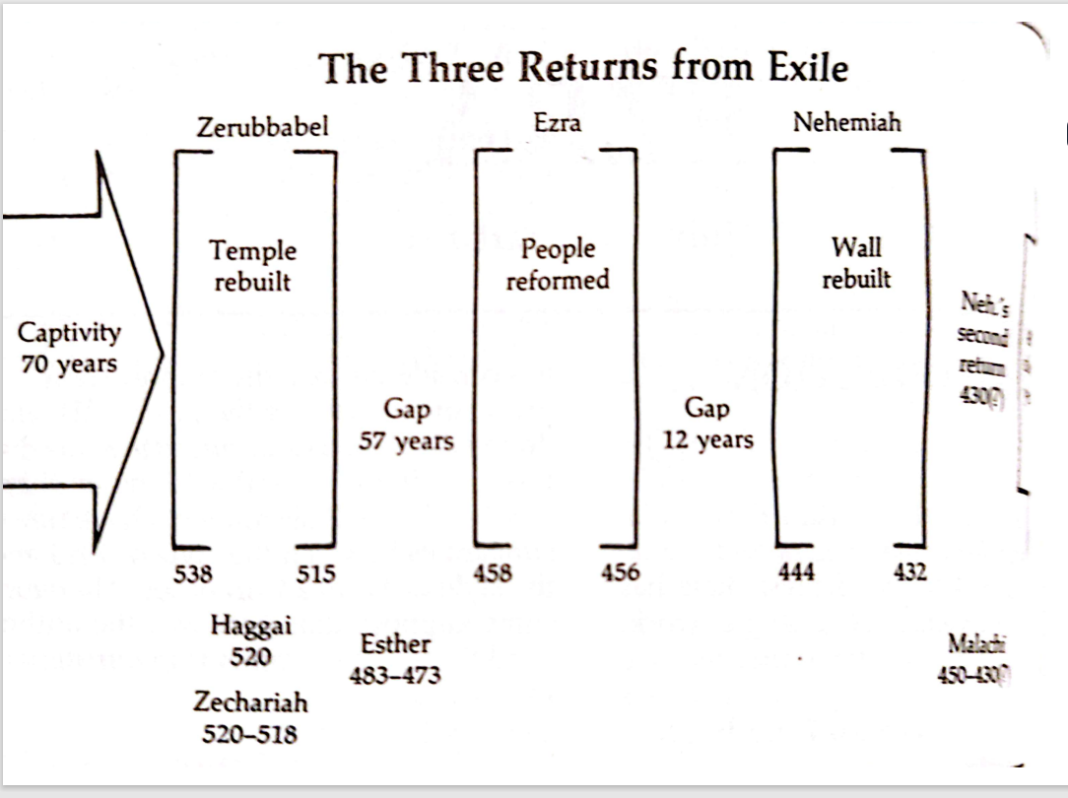
The Bible Knowledge Commentary

Nehemiah’s approach -The leader and the challenge of leadership
What are some of the challenges of leadership you know using the Nehemiah example?
- Making others understand your challenge. Hab 2:2
- Making people agree to your leadership.
- Getting people to join you to fix the problem.
See yourself as a leader (everybody a leader?): Think of my analogy about the 11 football players and you will discover that every member of the team is a leader at his/her wing. Others may assist him/her from time to time: You are the leader because you can see the challenge at your spot more than every other person and you can re-organize if need be because you understand the challenge more than the others. It is your job to paint the challenge before others. Hab 2:2. Whose duty is it to make a vision plain? (That explains why most people hate the position of leadership) The challenge of making a vision plain is huge. Some may not agree, and some just may not get it.
- Identify the challenge: What was the challenge that Nehemiah identified and wanted to solve. Neh. 1:3-4, 2:3-8, Dan 9:24
  - How did he identify the challenge? By asking. How did Daniel identify the challenge? Dan 2: 2. By reading. Deut. 1:6, Amos 6:1-2 Message The beginning of the achievement of your purpose is concern. Comfort steals purpose by putting you at ease. If you are in love with ease in life, you may never accomplish your purpose. Some of the people that God has used to accomplish purpose in life were people who although were comfortable where they were, sought to inconvenience themselves to achieve God’s set purpose for their lives. Examples are Esther, Daniel, and Nehemiah. If you become too comfortable in your place and forget your purpose in life, you may be exhibiting ingratitude to the one that gave you that comfort.
  - What have you identified as the challenge of the church in Calgary and what have you identified as the challenge in ACCM.
  - What is the difference between Nehemiah and Hanani? 1:2, Psalm 137, Esther 4:1-4, I Sam 17:23-27
- Decide how to approach the challenge: What was Nehemiah’s decision? Remote or onsite? Confer with people or refuse to talk to anyone about it. Daniels Approach (Dan 2:17), Nehemiah’s approach, (Neh. 1:4), Abraham’s Approach (Gen 22:2-3), Paul’s approach (Gal 1:15-17)
  - Why do you think Nehemiah took that decision to be on site? Nehemiah could have begged the King to send someone to Jerusalem to do the work.
  - How did David decide to solve his problem? Some problems may be unique, but some are similar. I Sam17:40 – Start from what you know.
- Start your plan: Planning is a process of deciding what to do about the project before you start the project.
  - Pray- Know when to pray and when to work Ecc., 3:1. It is best to start every plan with prayers.
  - Based on your evaluation of the situation, decide on the way forward
- Why is it important to fulfil our purpose in life?
  - A fulfilled purpose opens the door for our miracles. Our blessings are hidden in the fulfilment of our purpose. I Kings 17:8-16, II Kings 4:8-17.
- Why do some people not fulfil their purpose on earth?
  - Distractions – Fake pastors, insults in church, family challenges Luke 10:38,
  - Nonchalance: Neh 1: 2-3, I Sam 17:26
  - Anxiety: Matt 6:31-34
  - Ignorance I John 4:1, Hosea 4:6
  - Misunderstanding of mission: Numbers 13:17-20, 26-33

- Analyze Nehemiah’s strategy.
- Pray: Why do we pray? Prayers activates the supernatural and removes us from the realm of worries. Human efforts alone cannot bring us victory and even if it does, the effort may be excessive. Compare and contrast the prayers of Nehemiah and that of Daniel. Dan 9 13-19, Neh. 1:6-11 (focus on verse 19 in Daniel and 11 in Nehemiah)
- Seize the opportunity to talk to his boss after 4 months. Neh. 1:1 2:1- What did Nehemiah pray for, for four months? Was it because he had no faith? Nehemiah explains the reason for his sadness and the kings takes it from there. This perhaps talks about the relationship between Nehemiah and the king. Be careful how you ruffle relationships because you never know when you will need it.
- Request for letter of passage through the regions beyond the river. 2:7. Take advantage of an open door. Rev 3:8, I Cor 16:9 The beginning of error in life is not to identify when a door is opened. You need prayer to show you these doors when they open.
- Request for resources to help with the building. 2:8. Explain Verse 8b. And the king granted them according to the good hands of my God upon me. (Grace and favor). Make use of the resources available to you for kingdom work. - Finance, knowledge, access,
- Why will the king provide guard even when he did not request for it? The king provided his army with him. 2:9, (Favor) Obedience and service to God brings favor - Prov 3:1-4, Esther 2:17. I spoke about the priming of favor in one of my messages. That a woman gets the gift of a child is favor but pregnancy will not fly in the air neither is your conjugal relationship the reason why the woman got pregnant
- Opposition (physical or spiritual) even in the face of obedience: Compare and contrast the opposition experienced by Daniel and the one experienced by Nehemiah. Dan 10:12-14, Neh. 2:10, 19. Notice the progressive nature of the opposition of Sanballat in Tobiah: 2:10. Why will someone be opposed even when he is in God’s will? There are people who will be angry at you for no reason.
- He was in Jerusalem for three days before embarking on the reason for his mission. Why could he have done that and what lessons do we learn from that? Mark 6:31, Deut. 5:12-14
- He went to inspect the work. 2:11-16. What is the importance of doing a proper assessment of the work before starting. There is part of military that is so important for the success of any war and it is called recce, a short word for reconnaissance (intelligence gathering). Recce is not planning. You use the recce result for planning Joshua 2:1, Num 13:1-2
- Making the vision plain to the people 2:17 – these people saw the wall challenge so why did they not do something about it?
- What was the importance of telling them about his favor with the king? 2:18.
What are your strategies to accomplish the challenges you have identified in the church in Calgary and what are your plans to fix the challenges you have seen in ACCM?
How did Nehemiah respond to his critics to enable him focus on his purpose? 2:19-20. I Sam 28:28-29.
What was the substance of his response? Faith and work

